WORKORDERS DATASET

<https://docs.google.com/spreadsheets/d/1N4zHsmIQ3BGR4SZgnZIH2DLbPKvt1_0RaXG6po41Slk/edit#gid=0>

**ASSIGNMENT 1**

**Pre-requisites:**

* MS Excel
* WorkOrders.xlsx

**Scenario:**

You have been given an Excel file containing details for several work orders taken up by a company. Perform the following analysis on the given dataset:

* Create a new table that contains the valid number of technicians allowed for each service type, as shown below.

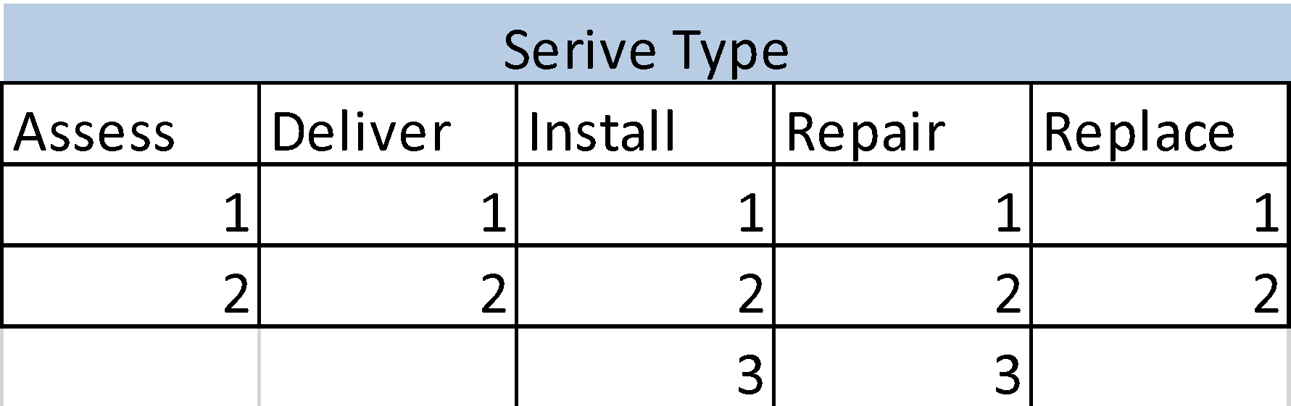

**ASSIGNMENT 2**

[**https://docs.google.com/spreadsheets/d/1N4zHsmIQ3BGR4SZgnZIH2DLbPKvt1_0RaXG6po41Slk/edit#gid=0**](https://docs.google.com/spreadsheets/d/1N4zHsmIQ3BGR4SZgnZIH2DLbPKvt1_0RaXG6po41Slk/edit#gid=0)

**Pre-requisites:**

* MS Excel
* WorkOrders.xlsx

**Scenario:**

You have been given an Excel file containing details for several work orders taken up by a company.  Perform the following analysis on the given dataset:

* Using the table created in the previous activity, create named ranges for each service type such that each range contains the respective technician counts.

**ASSIGNMENT 3**

**Pre-requisites:**

* MS Excel
* WorkOrders.xlsx

**Scenario:**

You have been given an Excel file containing details for several work orders taken up by a company. Perform the following analysis on the given dataset:

* Create a data validation over the existing “Techs” column such that the value in each row is as per the structure defined in the table created in activity 1.

**ASSIGNMENT 4**

**Pre-requisites:**

* MS Excel
* WorkOrders.xlsx

**Scenario:**

You have been given an Excel file containing details for several work orders taken up by a company.  Perform the following analysis on the given dataset:

* Create a pivot table that contains the total revenue and count of services done across all service categories for various technician counts.